Software Development Life Cycle (SDLC) for Ticket System

Name: Syed Yousuf Subzwari  
ID: 20240259

I had to design the Ticketing System as part of my assessment task, which was a great learning opportunity because I had to explore using variables and different python expressions in a practical program instead of individual practice. The objective was to develop a system capable of handling support tickets from company personnel.

Working on this assessment was very troubling especially when I was a little lost on where to start but managed to figure it out with the help of suggestions from lecturers and the lecture slide examples.

With the overview in mind, I had to consider the requirements mentioned. This includes understanding the functionalities required, such as ticket information, submission, response handling, and ticket logging.

Then came the task of translating the requirements into specific parts, breaking it down to make it simpler to individually tackle. For example, the creation of the Ticket class, methods to handle ticket submission, response, resolution, and reopening.

Additionally, the requests such as the unique password change response with the particulars of the generated password and the closing of the ticket after requiring much more planning to implement so I had to look up how it would be possible.

A basic diagram to show the design plan for the ticket system in flowchart form:

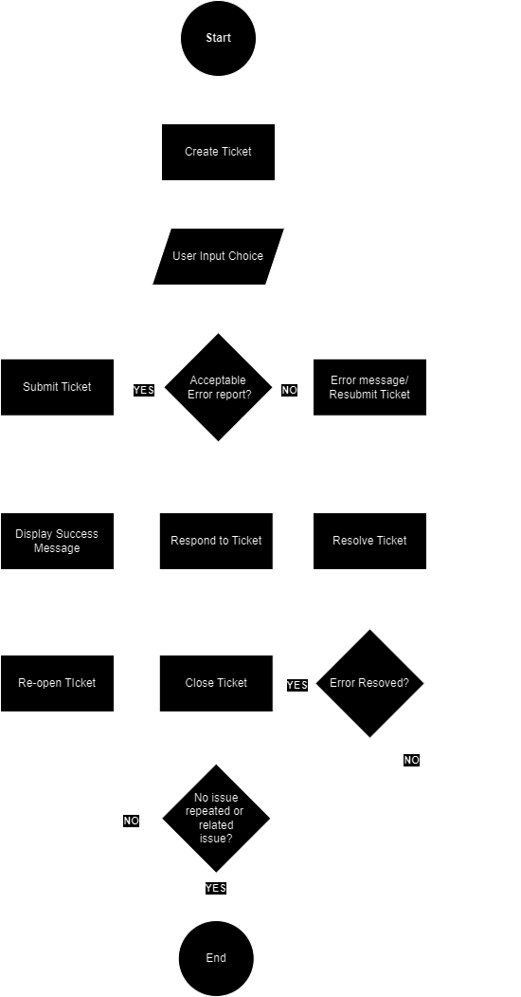

Had to add a few loops in for when errors showed up when testing the code for errors but learned a lot about their use and types too.

Basic setup based on OOP we studied, and essential set up to later ensure unique tickets and for calculating the statistics for the tickets, how many open, solves, re-opened and as such.

Regardless, I tried several times but couldn’t get it to work correctly, it either worked only for certain ticket types or for some of the process.  
  
Some example tickets that while following the format are manually coded in but still count for the total tickets in the system (ticket # 2001 – 2004)

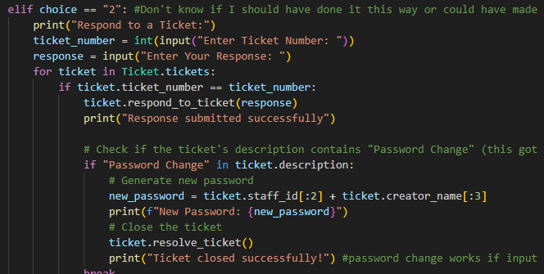

This ended up messy as I couldn’t figure it out till I looked up ways to use python expressions more extensively online, the addition of a separate password generator was troublesome as well, easy if its randomized but the specific components based on earlier inputs took a while to figure out.  
  
Still isn’t perfect but at least still works.  
  
Also learned about the choice function which helped set up the different results to input in a much cleaner and easier way.  
  
the /n (new line) function helped make things cleaner and simpler

With additional research and guidance from lecturer, figured out how to better plan and sort out my mess of a program.

To clean it up I had to rework a lot of the code from scratch, some based on advice, other references and also added some missing input data I realized I left out initially such as viewing a ticket and its details.

Sorted out a “main menu” style format as suggested.

The resulting code is much cleaner although much longer too, fixed issues and indention/placement issues. As of current testing the ticket system works.

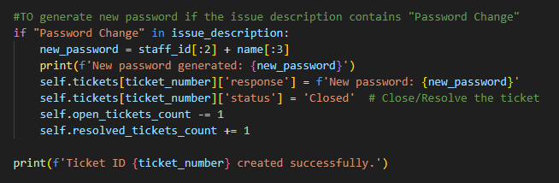

# References

*Giraffe Academy*. (n.d.). Retrieved from https://www.giraffeacademy.com/programming-languages/python/for-loops/

*LinkdIn Learning*. (n.d.). Retrieved from https://www.linkedin.com/learning/programming-foundations-fundamentals/welcome?u=36492252

*Linkdin Learning 2*. (n.d.). Retrieved from https://www.linkedin.com/learning/programming-foundations-fundamentals-3/the-fundamentals-of-programming?resume=false&u=36492252

*Stack Exchange*. (n.d.). Retrieved from https://codereview.stackexchange.com/questions/263171/ticketing-program-using-python-3

*Stacked Overflow*. (n.d.). Retrieved from https://stackoverflow.com/questions/62124199/python-choices-having-a-variable-value-for-number-of-times-the-choice-can-be-ca?newreg=a75c509d48c946608a9a4baf604df205

*w3schools*. (n.d.). Retrieved from https://www.w3schools.com/python/ref_list_append.asp